

**Company analysis report**

**Retail Industry**

**J Sainsbury Plc and Tesco Plc**

**Portfolio Task 2: Macro Environment**

**Module Name: Project -Finance and Investment**

**Table of Contents**

**1.** **Introduction** 3

**2.** **Review of the world’s global economy** 3

**3.** **PEST Analysis of J Sainsbury Plc and Tesco Plc** 4

**3.1 Political:** 4

**3.2 Economic** 4

**3.3. Social:** 5

**3.4. Technology:** 6

**Conclusion** 7

**References** 8

# **Introduction**

This report provides a concise analysis of the macroeconomic factors impacting J Sainsbury Plc and Tesco Plc. Through a PEST framework, it evaluates political, economic, social, technological and influences, offering insights crucial for strategic decision-making in the retail sector.

# **Review of the world’s global economy**

Tesco and J Sainsbury are large retailers, highly sensitive to macroeconomic conditions. GDP growth, inflation rates, and unemployment all have a direct impact on consumer spending. In a strong economy with low unemployment and high consumer confidence, these businesses tend to thrive because individuals have more spare cash for groceries and other retail items (annual report 2022).

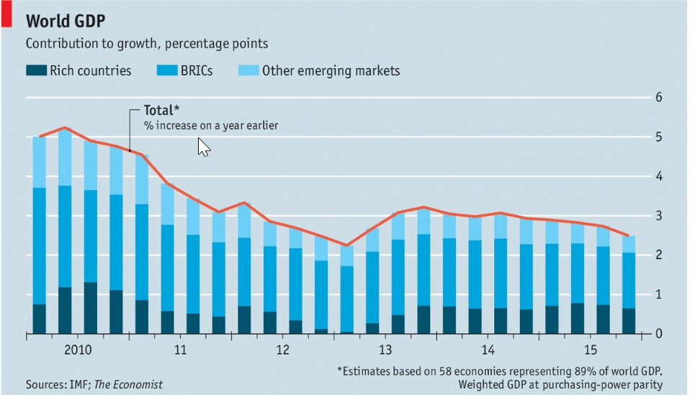

(Source: The Economist)

# **PEST Analysis of J Sainsbury Plc and Tesco Plc**

In analyzing the macroeconomic environment pertinent to J Sainsbury Plc and Tesco Plc, it is imperative to delve into the PEST factors that significantly influence their operations and performance. This analysis will scrutinize the Political, Economic, Social and Technological facets shaping the landscape for these retail giants.

## **3.1 Political:**

Both company Tesco and Sainsbury's face many government limitations on food safety, labeling, labor laws, environmental standards, and taxation, all of which can have a substantial influence on their operating costs, supply chain, and overall profitability. Changes to minimum wage standards and plastic packaging requirements, for example, have an impact on their bottom line. Tesco responded to rising wage requirements by announcing staff pay increases (BBC News), and both corporations are dedicated to eliminating plastic packaging to fulfill environmental standards. Trade policies, particularly post-Brexit, influence the price and availability of imported products. According to Tesco CEO Ken Murphy, the implementation of customs procedures and duties has increased strain on their supply networks. Compliance with UK Food Standards Agency rules has encouraged Sainsbury's to improve supply chain transparency (Sainsbury's Food Safety Report). Tesco has committed to net-zero carbon emissions by 2050 as part of its environmental strategy, whereas Sainsbury's wants to reach carbon neutrality and minimize plastic packaging. Furthermore, corporate tax reforms, such as the UK's intention to raise the tax rate from 19% to 25% by 2023, would force both corporations to reconsider financial strategy and perhaps modify pricing, investment, and development plans (Financial Times).

## **3.2 Economic**

The structure of the economy has a substantial influence on enterprises such as J. Sainsbury and Tesco, which gain from economic circumstances. GDP growth, high inflation rates, and growing unemployment all have an impact on consumer buying patterns. For example, the UK saw inflation rates of 9.1% in 2022 and 10.1% in 2023 (ONS), forcing consumers to be more cautious about their purchasing during economic downturns. In order to solve these issues, Sainsbury's increased the number of products at entry-level prices and concentrated on offering excellent value through competitive pricing. Tesco has also made adjustments to its product pricing and marketing plans in an effort to keep customers loyal and control the demands of inflation on disposable money.

Tesco showed endurance in a difficult market by reporting a rise in sales for the fiscal year 2022. But the business also recognized the difficulties brought about by the recession, and as a strategic reaction, it launched an endeavour to save £1 billion by improving operational efficiencies. Sainsbury’s, on the other hand, reversed a previous loss and recorded a statutory profit before tax of £854 million, indicating excellent management despite economic challenges.

## **3.3. Social:**

The ability to analyze society’s social phenomena and demographics is an important tool for the retailers to target their customers by the products effectively. Completely J Sainsbury and Tesco under these conditions have to learn how and adapt to like changing consumer preferences, lifestyles and cultural trends (Henry, 2022). Factor like an increased aging population, more health minded individuals and e-commerce have created a shifting in the retail environments (Moura, 2021). Tesco has responded to these customer demands by increasing the selection of plant-based foods and emphasizing the use of less plastic. Additionally, according to Sainsbury's, 72% of its protein sales are now plant-based or meatless, reflecting the trend in society toward sustainability and wellness. Furthermore, problems like sustainability and ethical sourcing have become major ethical issues leading to consumer’s fond attachment to particular brands and thus forcing companies to become socially responsible. Sustainability report demonstrates the rather poor performance of Tesco: develop more transparency (score – 29%) and provide more support for farmers (score – 15%). Yet with the Staff Scores of 42% is the company's feature. However, a 5% score on gender equality, as much as it stresses a top concern that should be addressed in a timely manner, possibly through supplier code of conduct approach, reflects other areas that must be tackled in the future. as their report of 2023 by Oxfam above states. Low sustainability ratings for Sainsbury's, including an overall score of 18% and a transparency score of 8%, point to inadequate reporting and accountability, which undermines consumer confidence and may reduce the company's capacity to compete in the market. Even while the greater 38% for workers is better than average, it still points to possible violations of labour laws that have an impact on production and employee satisfaction. They exhibit inadequate social responsibility practices, as evidenced by their 17% assistance for farmers and 10% gender equality, which will probably impede the establishment of ethical businesses and long-term viability.

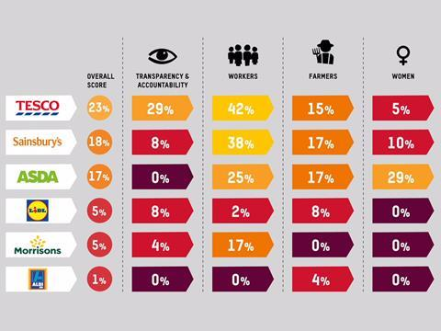

**Figure 1 shows: Tesco and Sainsbury’s Sustainability Rating**

## **3.4. Technology:**

The swift progression of technological developments not only encourages creativity but also draws attention to the persistent difficulties faced by the retail industry. Big participants in the market, including Tesco and J. Sainsbury, have made large investments in cutting edge technologies like automation, AI, and data analytics with the goal of improving both consumer pleasure and operational efficiency (Rashid, 2023). The COVID-19 pandemic and changes in worldwide consumer behaviour have accelerated the growth of e-commerce, which has been a major topic of concentration. Tesco has made major investments in its digital platforms and marketing tactics, resulting in enhanced online consumer experience and increased operational efficiencies. Tesco has seen a 2% increase in sales since 2018 as a result of this strategy, even in the face of inflationary pressures that they have managed through supplier partnerships.

Conversely, Sainsbury's has observed that more than 80% of its Argos purchases originate online, showing a notable transition towards e-commerce. Both retailers have incorporated artificial intelligence (AI) and machine learning into their inventory management and supply chains, which has reduced costs while improving the efficiency and dependability of service delivery. Sainsbury's diminishing revenues, however, underline the urgent need for ongoing technical innovation and illustrate the difficulties in sustaining market relevance in the absence of regular reinvention."

# **Conclusion**

Tesco Plc and J Sainsbury Plc's success or failure is largely dependent on the macroenvironment. These businesses get an understanding of the intricate relationships between politics, economics, society, technology, law, and the environment via the use of PEST analysis. Supply chains, customer confidence, and product customization are impacted by variables including governmental stability, economic situations, and sociological changes. Through the analysis of quantifiable, controllable, and predictable consumer-based macroeconomics, these merchants may effectively manage risks and capitalize on possibilities for sustained success.

# **References**

Bentham , J. (2018) Competition watchdog launches probe into Asda–Sainsbury’s merger. *The Pharmaceutical Journal* [online]. 22 (3). <https://www.proquest.com/scholarly-journals/business-economics-news-sainsburys-asda-decades/docview/2210884602/se-2>

Henry, J. (2022) *Writing at the crossroads: a linguistic analysis of academic business report writing at a modern UK university* *etheses.bham.ac.uk*. 6 December 2022 [online]. Available from: <http://etheses.bham.ac.uk/id/eprint/13048> [Accessed 25 June 2024].

Johnson, G., Whittington, R., Regnér, P., Angwin, D. and Scholes, K. (2020) *Exploring Strategy* *Google Books* [online]. Pearson UK. Available from: [https://books.google.com/books?hl=en&lr=&id=ieksEAAAQBAJ&oi=fnd&pg=PT25&dq=Johnson.](https://books.google.com/books?hl=en&lr=&id=ieksEAAAQBAJ&oi=fnd&pg=PT25&dq=Johnson)

Moura, M.B.L. de (2021) *Equity Research in Food & Retail Industry - TESCO PLC* *www.repository.utl.pt*. 1 October 2021 [online]. Available from: [http://hdl.handle.net/10400.5/23303.](http://hdl.handle.net/10400.5/23303)

Rashid, A., Rasheed, R., Rahi, S. and Noor Aina Amirah (2024) Disruptive factors of vendor-managed inventory in the manufacturing industry. *Supply chain forum* [online]. (4), pp. 1–12. [Accessed 29 April 2024]. <https://doi.org/10.1080/16258312.2024.2330913>

Rashid, C.A. (2023) PESTEL Analysis and Porter’s Five Forces as marketing tools to evaluate Morrison’s performance and strategy. *Journal of Global Social Sciences* [online]. 4 (15), pp. 75–83. <https://doi.org/10.58934/jgss.v4i15.187>